- January 2. February 3. March 4. April 5. May 6. June 7. July 8. August 9. September 10. October 11. November 12. December
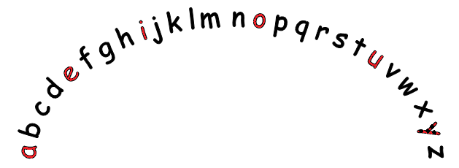
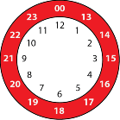
7, 14, 21, 28, 35, 42, 49, 56, 63, 70, 77, 84
8, 16, 24, 32, 40, 48, 56 64, 72, 80, 88, 96

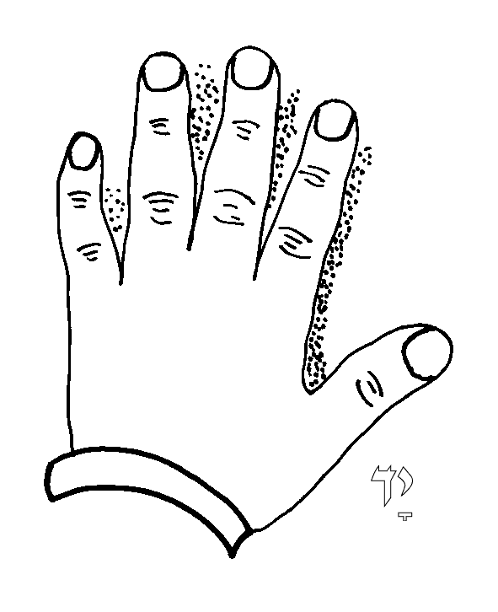

Openers: We…She… The… My… I… First… However… Next… Another thing… Never… I actually… Due to… An important thing… Then…
Connectives: and but so then because when although while also besides even though never the less in addition to despite

do not don’t
I am I’m
that is that’s
we would we’d
you are you’re
beautiful – boys eat apples under trees in France until lunch here
because - big elephants can always understand small elephants there
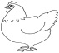
said – say and it’s done where
when

1 2 3 4 5 6 7 8 9 10 11 12 13 14 15 16 17 18 19 20

